**Log book**

**Reinaldo Maslim**

**Anti-sway controllers for Crane**

Week 1-2

In the first two weeks, initial literature review was done in order to understand the motivation and current status of anti-sway crane controllers in the industry. The swaying angle of the load has been a well-known control problem in seaports and manufacturing industry. It has attracted numerous solutions; yet still require continuous effort to develop a reliable and applicable for future portable sea ports. Anti-swaying is now mostly conducted manually by a crane operator, even though many assistive technologies for anti-sway are available in the market. Anti-sway crane control is not an easy and straightforward task due to its underactuation, coupled dynamics, and presence of uncertainties in its working environment.

From our observation, there are at least three approaches that have been taken to address the problem, namely:

1. Open-loop control scheme by input shaping
2. Closed-loop control scheme with sway-angle estimator and feedforward controller
3. Closed-loop control scheme by disturbance observer and robust controllers

The variables in each approach were taken into account because many of the research papers are dealing with only a particular situation. Next, we define the container transfer process from the simplest stage by eliminating wind disturbance, length of rope variation, and container mass variation. The governing equations of the system were derived by using Langrangian equations of motion. And then we build the model of the system using MATLAB Simulink.

Week 3-4

An open-loop control by input shaping method was designed and tested in MATLAB Simulink. The actuator’s input (trolley’s speed) will be given pre-defined as a function of initial and final state to achieve minimum transfer time while keeping the sway-angle under a tolerable range. This method was firstly developed from the experience of skilled crane operators and can be verified by a few simple equations. Theoretically this method will succeed as our simulation study had confirmed. However due to the lack of feedback, the application in real-time is limited to very small disturbance environment i.e. indoor crane operations.

Another control scheme consisting of a position controller and sway-angle feedforward compensator was built with MATLAB Simulink. A conventional PD (proportional-derivative) controller was assigned as position controller which takes in reference position from reference trajectory generator block and outputs desired velocity to the plant. In order to suppress undesirable swaying of the load, another velocity term which is proportional to the estimated sway angle is added based on superposition. The reference trajectory must be feasible in terms of the actuator’s constraints. Results showed satisfactory position tracking and the compensator is able to suppress sway angle significantly.

Week 5-6

We proposed to build a scaled down crane model as a test-bed. The proposed design is very simple consisting of aluminum frame as support, belt linear guide, one motor for trolley’s transverse motion, and another motor as a hoisting mechanism. A few parts which were not standard parts, have to be designed with specific dimensions using Solidworks. 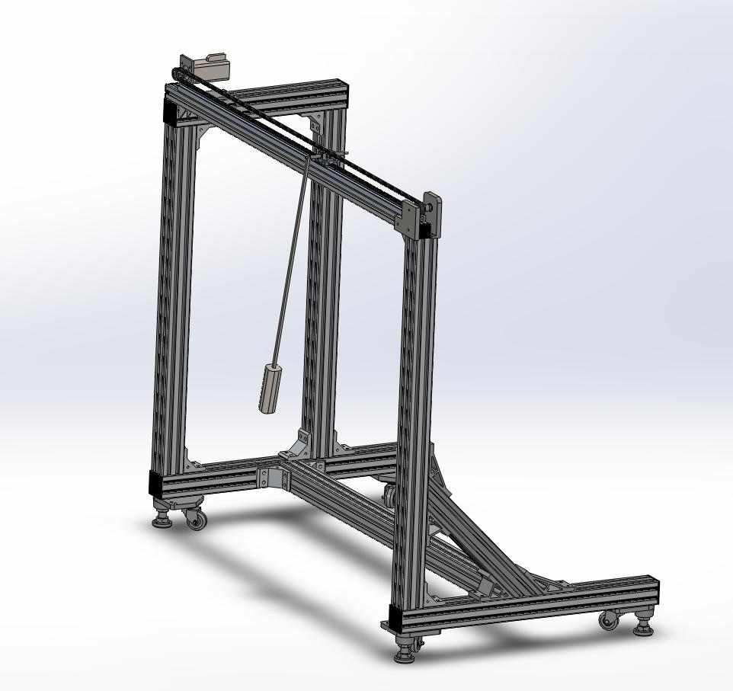

Week 7-8

During these weeks, the mechanical parts were sent to fabrication or purchased. I spent my time on preparing the electrical components eg. Motor drivers, motion interface, power cables, as well as getting introduced to LABView software.

In the practice, the usage of state observer or disturbance observer is very crucial because of the uncertain conditions of the seashore environment and absence of satisfactory sensors.